|  |  |
| --- | --- |
| **Name (in Romaji):** | 🡪 |
| **Student Number:** | 🡪 |
| **Class Day + Period**  **(examples: Monday 2, Friday 3):** | 🡪 |

**TP Chapter 06 Quiz**

**Chapter 6.1**

**Activity 1: Can and Can't**

As you learned in Chapter 6, the difference between *can* and *can't* can be confusing even for native speakers. One key is to lengthen the vowel and raise the pitch for *can't*, making it a stressed word. The other key is to lower the pitch and reduce the vowel for *can*, making it an unstressed word.

**Predict**

Before you listen, look at the following sentences. Review the chart on p. 80 to help you predict which words are stressed and which words are not. For each sentence below, choose all of the words that would be stressed.

1. She can speak French.

a. She, can

b. can, speak

c. speak, French Answer 🡪

2. Paul can't go to the store.

a. go, store

b. Paul, to, the, store

c. Paul, can't, go, store Answer 🡪

3. The students can't open the classroom door.

a. the, students, can't, door

b. students, can't, open, classroom, door

c. open, the, classroom, door Answer 🡪

4. The teacher can play the piano.

a. teacher, play, piano

b. teacher, can, play

c. play, the, piano Answer 🡪

5. The cat can't climb trees.

a. cat, can't, climb

b. cat, climb, the, trees

c. cat, can't, climb, trees Answer 🡪

6. Anna can't take chemistry this semester.

a. can't, take, chemistry, this

b. Anna, can't, take, chemistry, semester

c. Anna, take, chemistry, semester Answer 🡪

7. Meet us at the mall at seven.

a. Meet, us, mall

b. us, mall, at

c. Meet, mall, seven Answer 🡪

8. I can borrow my uncle's car.

a. I, borrow, car

b. can, borrow, uncle's

c. borrow, uncle's, car Answer 🡪

9. Can you join us for dinner tonight?

a. you, us, dinner

b. us, for, dinner

c. join, dinner, tonight Answer 🡪

10. Can't he come to the movies on Friday?

a. can't, he, come, movies

b. can't, come, movies, Friday

c. to, movies, on, Friday Answer 🡪

**Listen**

Listen to the sentences as you look at your predictions. Change any answers that you think are incorrect.

**Repeat**

<><><><><><><><><><><><><><><><><><><><><><><><><><><><><><>

**Chapter 6.2**

**Activity 2: Syllables and Schwa**

**Listen**

Listen to the sentences. Write the letter of the sentence that you hear.

1. a. Their sport is very important to him.

b. Their support is very important to him. Answer 🡪

2. a. It's cute.

b. It's acute. Answer 🡪

3. a. He just appeared in the window.

b. He just peered in the window. Answer 🡪

4. a. Sam was rested.

b. Sam was arrested. Answer 🡪

5. a. Peter watches every cent.

b. Peter watches every ascent. Answer 🡪

6. a. Do you have an idea?

b. Do you have an I.D.? Answer 🡪

7. a. That's Pete's.

b. That's pizza. Answer 🡪

8. a. The bag belongs to Lee.

b. The bag belongs to Leah. Answer 🡪

**Repeat**

Listen to the sentences again, repeating after the speaker. Keep practicing until you feel comfortable pronouncing the schwa syllables.

<><><><><><><><><><><><><><><><><><><><><><><><><><><><><><>

**Chapter 6.3**

**Activity 3: Clear Vowels**

Review the fifteen clear vowels on page 108. Listen and track the vowel sounds as the speaker says the words.

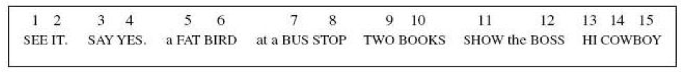

**Listen**

Listen to the speaker pronounce the following phrases. Review the vowel chart above to see the numbers for each clear vowel sound. Write the number of the clear vowel sound used in the underlined words. Be sure to write the number, not the word. For example, write *7*, instead of *seven*.

1. the cat's hat 🡪

2. three trees in the breeze 🡪

3. his thin pins 🡪

4. the boy's toy 🡪

5. the cook's books 🡪

6. a purple turtle 🡪

7. the cost of the loss 🡪

8. a great day 🡪

9. try my rice 🡪

10. Bette's wet pet 🡪

11. the rusty and dusty bus 🡪

12. my father's job 🡪

13. Joe's toe glows 🡪

14. glue Sue's shoes. 🡪

15. how now brown cow 🡪

**Repeat**

Listen again, repeating each phrase after the speaker.

<><><><><><><><><><><><><><><><><><><><><><><><><><><><><><>

**Chapter 6.4**

**Activity 4: Mouth Matching**

Look at the mouth positions.

Position 1: Position 2: Position 3:

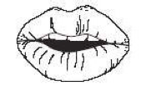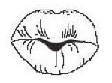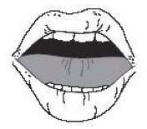

Listen to the phrases. (The words are not written for you.) Which mouth position matches the vowel sound that you hear?

1. a. 1 b. 2 c. 3 🡪

2. a. 1 b. 2 c. 3 🡪

3. a. 1 b. 2 c. 3 🡪